1. Based in Victoria and operates in Victoria as well.
2. Main Activity is one of following:

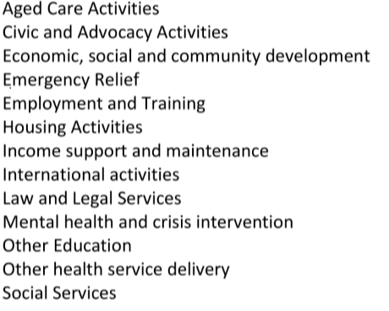

1. Re-define charity size
2. Delete charities whose total gross income is 0.
3. Make sure government grans <=total gross income
4. Income, revenue, expenses, liability is no negative values.
5. Government grants are less than 25,000 for small and extra small charities; less than 100,000 for medium charities and less than 1000,000 for large, extra large and extra-extra-large charities.
6. Employee expense / (Full time staff numbers+ part time staff numbers+ casual staff numbers) should be less than 300,000
7. Employee expense and total income differ by less or equal 25,000 for small charities.

Employee expense and total income differ by less or equal 100,000 for medium charities.

Employee expense and total income differ by less or equal 1000,000 for large charities.